# **MAR 653 - Homework 1**

**October 23, 2023**

Group 2

* Anna Khairi
* Logan Roach
* Mark Stiles
* Oliver Gunn
* Sachi Singh

# Executive Summary

* The data you analyzed: Customer data
* The segments identified
  + 3 segments (past time, health conscious, lifestyle)
* A brief (bullet or two) description of the segment preferences and profiles
  + Segment 1 - athletic for pure pleasure (past time)
  + Segment 2 - like sports, care about their health and enjoy it (health conscious)
  + Segment 3 - athletic pure competition (lifestyle)
* New products or features
  + Social Media Integration - sharable workouts, workout leaderboards between global users and friends
  + Nutrition Tracking - integrate with pre-existing companies (B-B engagement)
  + Product Warranties/ Insurance
  + Product Customization - Watch bands and faces, custom colorization
* Growth strategies
  + More subscriptions- converting free app users to subscription app users
  + App Advertising (Search Prioritization)
  + More purchases per person
  + New products
  + Software Environment Creation - take Wahoo’s pre-existing software and integrate into one dashboard for customer ease of use but also advertise the subscription service and other promotional events

# Analysis

## K-means

Developing an elbow plot with the data provided showed that three clusters provided value but a fourth cluster may also have provided additional value. We used the 3 clusters that were determined for us throughout the rest of the analysis but found it interesting to note.

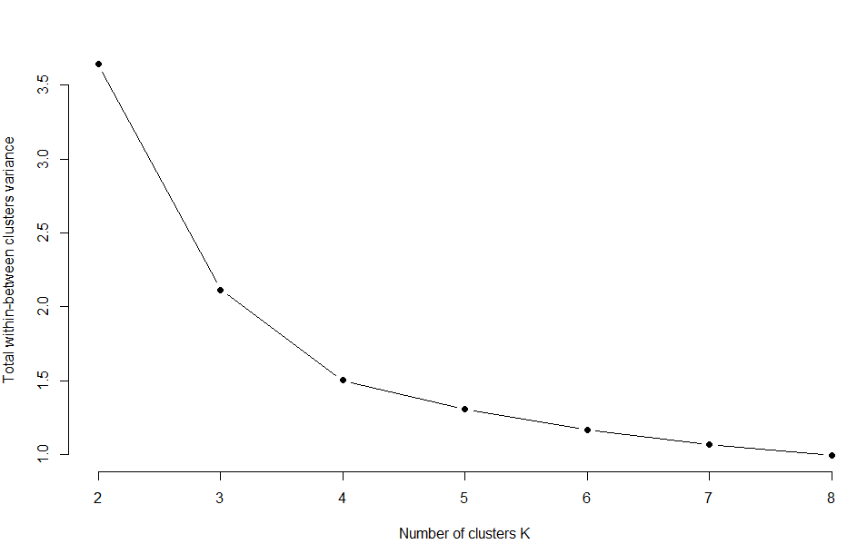

## Psychographics

Based on the answers to questions 1 and 2 provided there was a fairly clear delineation between the three segments. There were some minor overlaps between segments but it didn’t affect the overall analysis.

The first segment identified was as interested in being active as the other segments but with a higher focus on enjoyment and social engagement. They were also willing to spend more for a product they liked.

Segment 3 focused more on nutrition, performance and competitions. They would be more likely to purchase used or discounted products. They were more interested in maximizing the use of a product.

The second segment was in between the other two segments with a stronger lean towards performance but interest in enjoyment. There were less specific with their goals but were engaged in tracking and following sporting events.

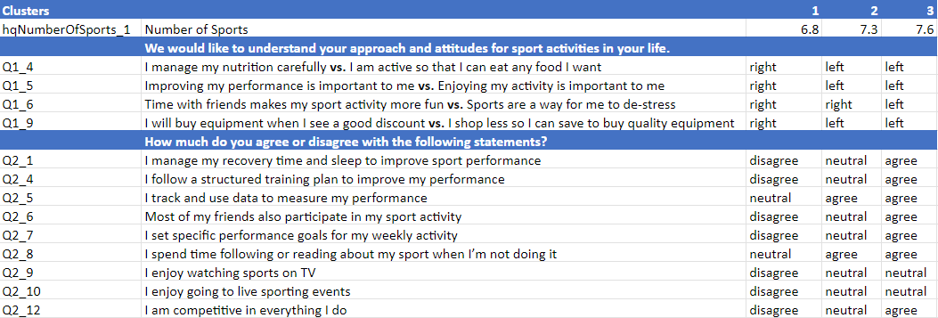

The graphs show a visual representation of the answers above with visible differences between the clusters for most of the answers. They had a similar trajectory which confirms the result of the table.

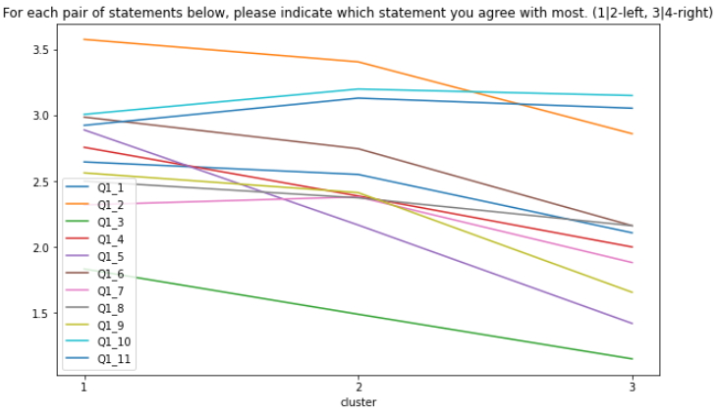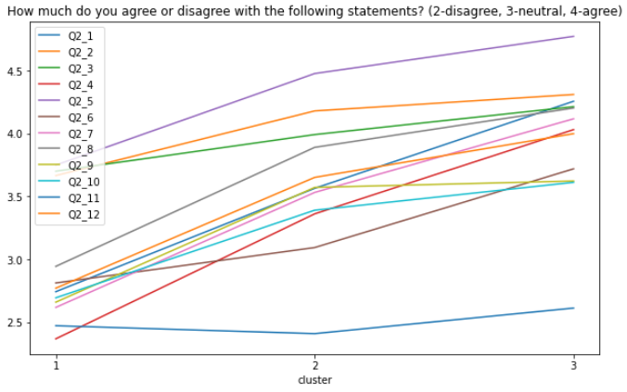

## Demographics

The segments did vary by age and gender but not enough that it would be a determining factor in segmentation outreach. The ages for segment 1 and 2 were within a half a year of each other where segment 3 was around 2 years younger. Enough to say that a slightly younger age band was more active and focused on performance but not such a difference in age that it would logically make sense to target that age. Their age could indicate they have more disposable income. It could also mean there’s room to grow in the 20’s age range.

Gender was similar in that the difference between each group wasn’t leaning heavily toward one gender or another but all groups did lean slightly more toward 1 (men) than 2 (women).

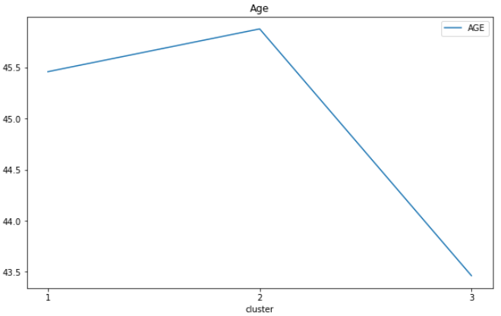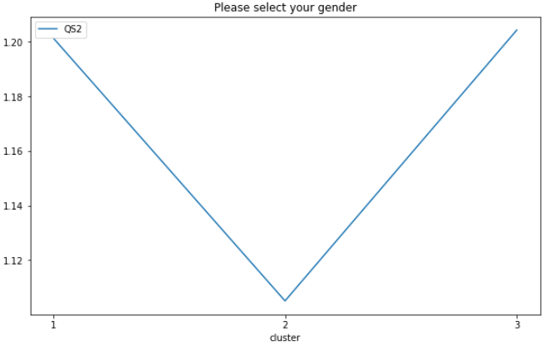

Taking a look at the age distributions, there’s likely a big opportunity for outreach to the 20-35 age range that could be future customers. They’re not engaged in large numbers and should be considered for early outreach if the prime customer age is roughly 45. Preparing them to join early could improve overall customer lifetime value.

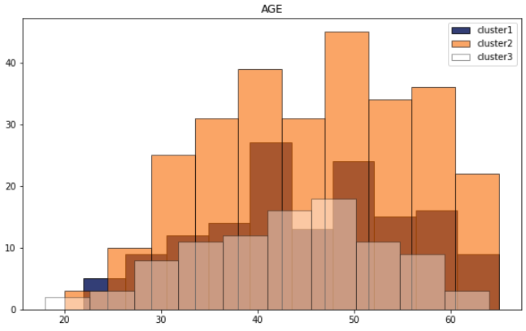

## Fitness Preferences

All segments owned similar monitoring accessories. All segments were using tracking products like GPS and heart monitors. They connected devices with their phones which were mostly iPhones but also not insignificant numbers of Android users. No segment used recovery trackers in significant numbers or devices without tracking. Tracking was essential to them all.



*Percent of Segment Using These Products*

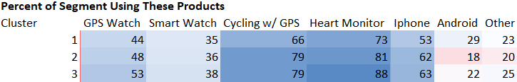

*Percent of Segment Using These Products (close up)*

All segments had similar exercise products. High percentages of all segments used the bike trainer and treadmill. There were noticeable levels of use for the rower, spin bike with or without screens, rowers, ellipticals, or smart bikes. No segment used the stair steppers in significant numbers. Overall all groups were heavy users of running or biking equipment. There wasn’t much difference between the segments except for treadmill usage. Segment 2 used the treadmill and rower at the highest rate but still within a narrow range of difference.

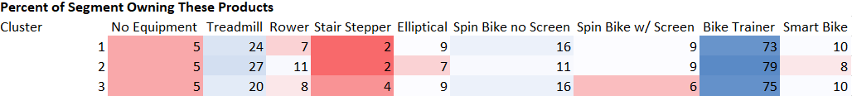

*Percent of Segment Owning These Products*

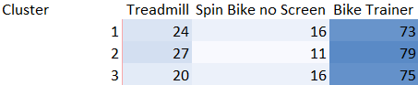

*Percent of Segment Owning These Products (close up)*

The athletic activities had some mixed results for the segments. Some activities had nearly the same activity level between segments and some had wide ranges between segments. Similar to the previous question, cycling, track running, all activities together and using an indoor trainer had consistently high levels in all segments. Running, triathlons and GPS use was significant but had gradations between the segments. Segment 1 had the least use of those and segment 3 had the highest which is consistent with the other findings that segments 3 had a higher commitment to competition and performance.

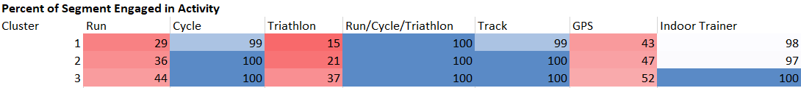

## 

By utilizing get_top_correlations, create_coor_heatmap, cor functions, coorplot, and sorting in R. The top 20 positive correlations within each cluster were produced along with a heat map. This is an important step to figure out what is really going on within each cluster and to understand the difference amongst each cluster. By utilizing cluster specific insights marketing campaigns can be super specific towards each cluster to maintain a healthy retention rate.

Cluster 1 Q2_9 (Enjoy watching sports on TV) & Q2_10 (Enjoy going to live sporting events): Correlation 0.559 People who enjoy watching sports on TV are also likely to enjoy attending live sporting events. Q2_4 (Follow a structured training plan) & Q2_7 (Set specific performance goals): Correlation 0.480 Those who follow a structured training plan tend to also set specific performance goals suggesting a more disciplined approach to their sport or activity. Q2_2 (Knowledge about sporting equipment) & Q2_5 (Track and use data to measure performance): Correlation 0.383 Individuals knowledgeable about their sporting equipment also tend to track and use data to measure their performance indicating a technical and informed approach to their sport or activity.

Cluster 2 Q2_9 (Enjoy watching sports on TV) & Q2_10 (Enjoy going to live sporting events): Correlation 0.443 Similar to Cluster 1, individuals enjoying watching sports on TV also tend to enjoy attending live sporting events, but the correlation is slightly less strong in this cluster. Q2_2 (Knowledge about sporting equipment) & Q2_3 (Maintain own sporting equipment): Correlation 0.388 People who know a lot about their sporting equipment also tend to maintain their own equipment indicating a hands-on approach and deep engagement with their sport or activity.

Cluster 3 Q2_9 (Enjoy watching sports on TV) & Q2_10 (Enjoy going to live sporting events): Correlation 0.637 This correlation is the strongest across all clusters, enjoyment of watching sports on TV and attending live events goes hand in hand. Q2_5 (Track and use data to measure performance) & Q2_7 (Set specific performance goals): Correlation 0.442.

## Intuition of Wahoo and Growth Strategy

Wahoo stated that they found their growth areas were spinning, running and new products or features for existing customers and the data is consistent with these assumptions. They also consider their customers to be the ‘tip of the spear’. One aspect of the results counter that assumption and indicate there are other growth segments they could focus on.

Cycling and cyclists make up a large majority of all segments and most use spin bikes without a screen. It might be that they don’t find them necessary or it might be a growth market. A gap in content could explain why those numbers are that low. Targeted content and screen accessories may increase the likelihood of use of those products and offer more paying membership service opportunities. The unexpected results of the survey indicate that segment 1 and 2 are less focused on pure performance and could overlap with Peloton’s core customer base of health and fitness users. Segment 3 does match most closely to their expectation of users who are preparing for the next race. Providing a space for less performance focused users wouldn’t damage their brand if they continued to maintain a strong offering for the core customer base training focused users. Even users who train professionally have recovery days.

The running segment is certainly a growth opportunity. Many of the customers are also runners. They would find value in more devices like watches, rings and smart clothes. Marketing targeted towards runners would be worth pursuing to grow that segment. More specific metrics toward running would also make sense to engage with them more precisely. The differentiation between the other brands could be treadmills that integrate better with devices and blend the overall user performance into a cohesive narrative of their growth. The Wahoo brand is known for high performance users and should use that credibility to win head to head with their competitors.

Existing customers don’t have a lot of gaps in product ownership to fill. All segments seem to favor similar products but it might be useful to make more sense of the data for the user. Answering questions like ‘Is diet or sleep affecting their performance?’ or ‘Which balance of workout and recovery days provide the best overall performance?’ could be valuable to engage users longer and identify which other data points to incorporate. SYSTM/Sufferfest training provides a lot of value for those focused on competitions but content could branch out to allow for other types of workouts similar to Peloton offering cool downs or supplemental stretching videos. Updated products with combined features like watches, heart rate monitors and gps products are often used and would continue to be a source of revenue. The bike trainer is the most used product by all segments and integrated accessories for it should be a primary area of expansion.

# Product and Feature Recommendations

We have identified and named three target segments: Past Time, Health Conscious, Lifestyle. Recommendations will be for each segment specifically.

### Past Time

* + - High Quality Features
    - Social Perks
      * Social Media Integration - Sharing Apps
    - Focused dashboard tools

From the average responses to survey questions, individuals in Cluster 1 engage in exercise more casually than those in other clusters where high quality features and structured workouts could engage the customer to being a more committed user. Those in cluster 1 seemed to be lightly engaged in exercising while also using it as a leisure activity and a tool to destress. Incorporating a user-friendly dashboard with structured workouts, promotional campaigns, and the Wahoo software apps could introduce casual customers into using more apps and products such as the subscription based app. Social media integration into the dashboard would also allow those who use exercise as a leisure activity to connect with others with a similar mindset.

### Health Conscious

* + - More entertainment
    - Social perks
    - Food Recommendations

Individuals in Cluster 2 occupy customers who enjoy exercising more and appear to favor a health conscious lifestyle where features such as nutrition tracking would offer those who are already dedicated to exercising further incentives for using Wahoo apps and products. While customers in Cluster 2 would rather use exercise as an opportunity to destress, accolades and leaderboards for friends and global users could convert customers who already have a focus on healthy living into more dedicated customers as they use the social media capabilities to connect with friends and other similarly minded people. Additionally, partnering with a company with access to software that has nutrition recommendations and tracking capabilities would not only retain customers in Cluster 2 but also customers inclined with a more competitive mindset.

### Lifestyle

* + - Discounts - every one should be on your equipment
    - Product Feedback Portal
    - Community program - yearly mvp awards
    - Newsletter / Event Reminders - they want to be informed
    - Social Perks
    - Stylized / Personalized Apparel
    - Streaming Content
      * Recap Races
      * Special Destination Trails (Hillside, Cityscape, Woods)
      * Personal Goal Recap (like facebook memories)

From the survey data Cluster 3 customers seem to be more dedicated in tracking their exercise progress while being the most competitive segment of the surveyed customers. Customers in Cluster 3 would benefit the most with a dashboard with Wahoo apps and social media integration as these customers are the most incentivized to use the subscription based services and share exercise progress with friends and compete on leaderboards. Other features catered to Cluster 3 customers could include promotions, features, and events. Customers in cluster 3 are also prime targets for integrating into higher tiered subscriptions at a higher cost but with access to virtual and in person promotions, features, and events.